

**(Affilated to Tribhuvan University)**

**Kathmandu, Nepal**

**COMPILER DESIGN AND CONSTRUCTION PRACTICAL**

**B.SC.CSIT**

**Submitted By:**

**Sagar Giri**

**Lab course Designed and instructed by:**

**Satya Maharjan**

**Q1. PROGRAM TO CHECK A STRING STARTING WITH '1' & ENDING WITH '0'**

For alphabet over Σ = {0,1}

**Solution:** 1 (1 + 0) 0*

**Program Coding:**

def check(inp): #Function to check first and last character

if(inp[0] == '1' and inp[-1]=='0'):

return True

else:

return False

print("PROGRAM TO CHECK A STRING STARTING WITH '1' & ENDING WITH '0'")

print("Enter a string to check")

inp = str(raw_input()) #Take input from the user

flag = check(inp) #Get the result

if(flag):

print("Correct")

else:

print("Incorrect")

**Output:**

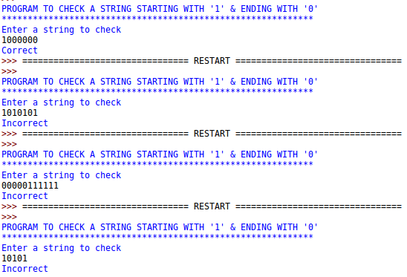

**Q2. All strings that ends with 00 for alphabet Σ{0,1}**

Solution: (0+1)*00

**Program:**

def check(inp):

if(inp[-1] == '0' and inp[-2]=='0'):

return True

else:

return False

print("PROGRAM TO CHECK A STRING THAT ENDS WITH '00'")

print("Enter a string to check")

inp = str(raw_input())

flag = check(inp)

if(flag):

print("Correct")

else:

print("Incorrect")

**Output:**

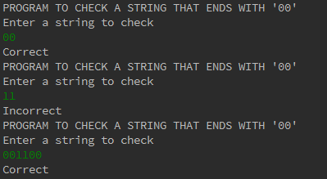

**Q3. Set of all strings that describe alternating 1's and 0's for alphabet Σ{0,1}**

Solution: (01)*+(10)*+(01)*0+(10)*1

**Program:**

def check(inp):

flag = False

chars = list()

for each in inp:

chars.append(each)

temp = 1

for i in range(len(chars)-1):

if(chars[i] != chars[temp]):

temp += 1

flag = True

else:

flag = False

break

return flag

print("SET OF ALL STRINGS THAT DESCRIBE ALTERNATING 1'S AND 0'S")

print("Enter a string to check")

inp = str(raw_input())

flag = check(inp)

if(flag):

print("Correct")

else:

print("Incorrect")

**Output:**

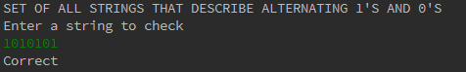

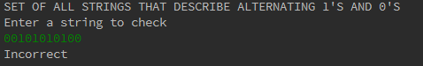

**Q4. Set of all strings that describe exact three 1's for alphabet over Σ{0,1}**

Solution: 0*10*10*10)=*

**Program:**

def check(inp):

lst = list()

i = 0

flag = False

for each in inp:

lst.append(each)

for elem in lst:

if(elem=='1'):

i+=1

else:

continue

if(i==3):

flag = True

else:

flag = False

return flag

print "PROGRAM TO CHECK A STRING THAT HAS EXACTLY THREE 1'S"

print "Enter the string to check"

input = str(raw_input())

if(check(input)):

print "Correct"

else:

print "Incorrect"

**Output:**

